Bending Effect Inspection on Hollow-Core Anti-Resonant Fiber based Terahertz Spectroscopic Gas Sensor

**Abstract:** In this study, a Hollow Core Anti-Resonant Fiber (HC-ARF) for gas sensing purpose with ultra-high sensitivity response has been designed and investigated. The proposed structure contains large hollow core and six thin-walled capillaries. The proposed HC-ARF based sensor also shows very low loss profiles. The values of propagation losses (mainly confinement loss) and material absorption loss of the sensor are in the order of 10-3. As the core is relatively large, along with fundamental modes (horizontally polarize mode and vertically polarize mode) some Higher Order Modes (TM01 mode, TE01 mode, HE21 (even) mode, HE21 (odd) mode, etc.) have been gained. But the fiber sensor also has good Higher Order Mode suppression ratio (HOMER) response. Besides sensing gas, it can be used for transmission purpose with single mode propagation. At the end of the study, the bending effects on relative sensitivity and propagation losses have also been demonstrated by bending the fiber with various bend-radii.

**Introduction:** Researches are being conducted for several decades to enhance the performance of optical fibers and to reduce the fabrication cost. The most successful outcome is Photonic Crystal Fibers (PCF). PCFs have immense potential in sensing sectors and so it is the most demanded technology now-a-days. Real life implementations of PFC based sensors are very feasible as PCFs have flexibility in design and cheaper fabrication cost with low-loss transmission. PCF has been used in non-linear devices, lasers, biosensors etc. Biosensors have many fields such as chemical detection, gas detection, temperature detection, pressure detection, detecting of diseases or damaged bio cells and so on [1-5]. Due to climate changes, it is important to detect the harmful gases such as CO2, N2O, CH4, CFCs etc. because these gases elevate the climate changes [6]. These gases have direct impact on increasing the temperature of the earth’s atmosphere permanently and have been damaging the protective ozone layer in the atmosphere [7,8]. So it needs not to say that, monitoring gases in the atmosphere is very important [9]. In prior works, gases would be detected by means of numerous sensors such as gas sensor based on capacitance [10], metal oxide [11], acoustic wave [12], electrochemical [13], colorimetric [14], sensor based on silicon nanowire [15], conventional gas sensor based on optical fibers [16] etc. But these gas sensors have various drawbacks such as bigger size, costly, worse response time, mode operations’ complexity and lower relative sensitivity [13,14].

Various types of PCF based gas sensors have been used recently as they have novel characteristics namely lowest confinement loss, modal birefringence, high relative sensitivity, zero dispersion wavelength, low or high non-linearity, bigger numerical aperture, endlessly single mode [17-20] etc. PCFs are categorized in three classes according to the confinement of light in the core region: (i) Porous Core PCFs, (ii) Solid Core PCFs and (iii) Hollow Core PCFs [21]. Hollow Core PCF (HC-PCF) shows better sensitivity performance than Solid Core or Porous Core PCFs [22-24] as HC-PCF confines more light into the core region by photonic band gap (PBG) effect technique. But there are some drawbacks of HC-PCF such as relatively high confinement loss and narrow bandwidth [25]. To overcome this, HC-ARF with wider hollow core has been designed in this study. The hollow core of the fiber is be filled with sample gas. HC-ARF traps the light inside the core by inhibited-coupling incident between the core and the claddings and also by anti-resonant effect [26,27]. HC-ARFs are proved to be the best candidate for gas sensing compared to Hollow Silica Waveguides (HSWs) and Hollow Core Photonic Band Gap Fibers (HC-PBGFs). HC-ARFs have low loss, broad bandwidth with high relative sensitivity in the Mid-Infrared (MID) region [28-31]. Terahertz (THz) light spectrum is a most talked topic among researchers and is being used for several decades. Gas absorption and spectroscopy based sensors are also being studied and used for long periods of time [32].

In this research study, a novel HC-ARF is inspected having a wider hollow core along with six non-touching capillaries as cladding. The study is based on gas absorption spectroscopy for 1.0 THz to 2.0 THz. These capillaries work as anti-resonant tubes along with the negative-curvature core. These capillaries are connected to the clad region of the fiber. The simulations of this design have already shown very high sensitivity responses along with wide effective mode area (EMA), low confinement loss (CL), lower effective material loss (EML) and very small crosstalk. These parameters are analyzed in the Fundamental Mode (FM) field distributions along with Higher Order Mode (HOM) field distributions. Also, the bending effects on sensitivity, CL and EMA due to the bending of the fiber having various bend radiuses (Rb = 15cm, 30cm, 45cm) are also studied.

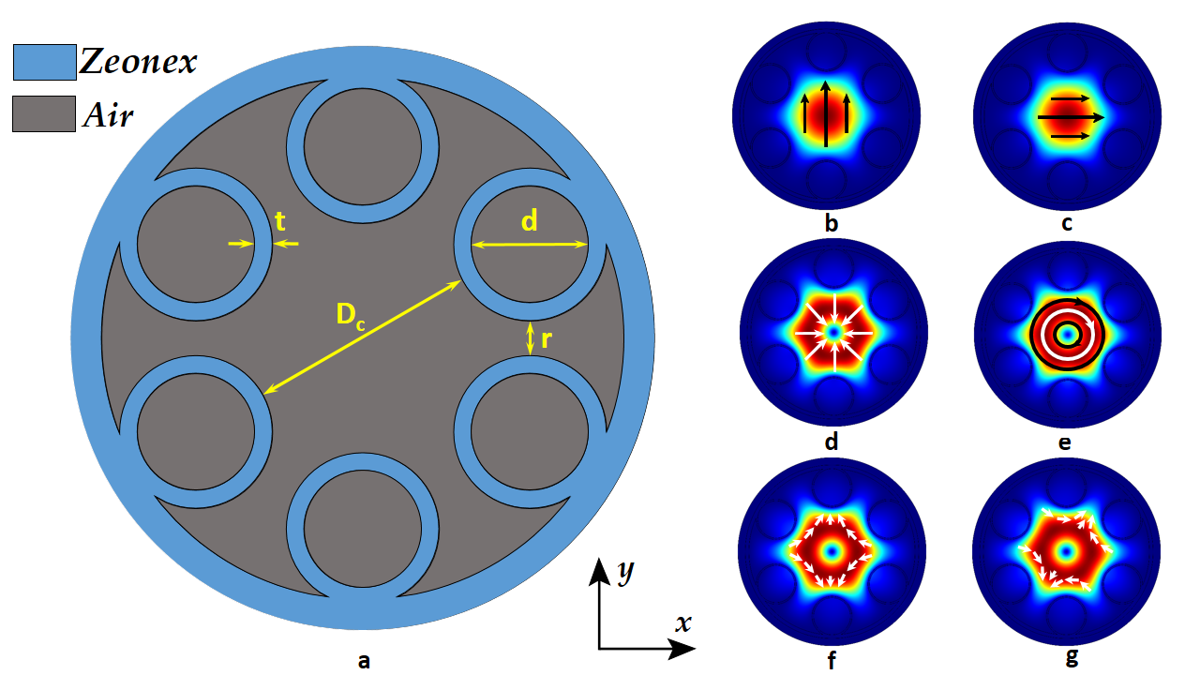

**Fig. 1.** Proposed HC-ARF and respective mode field distributions. (a) Geometric structure of the fiber with core diameter Dc = 2.4 mm, capillary tube diameter d = 1.0 mm, capillary tube thickness t = 0.09 mm and distance among capillaries r = 0.65 mm. Fundamental core modes – (b) HE11 (even) mode, (c) HE11 (odd) mode. Higher Order Modes – (d) TM01 mode, (e) TE01 mode, (f) HE21 (even) mode and (f) HE21 (odd) mode.

**Fiber Design and Methodology:** In Fig. 1, the geometric structure of the proposed model fiber as well as mode field distributions are shown. The proposed HC-ARF has simple structure with six disjoint capillary tubes which work as claddings and generate anti-resonant effect [33]. These disjoint anti-resonant capillary tubes are connected to the outer layer of the fiber. The single core diameter, Dc = 2.4 mm (this distance is between two capillaries located opposite side of the core) is chosen for this fiber. All capillary tubes are of same size having diameter, d = 1.0 mm and tube’s thickness, t = 0.09 mm. The adjacent two capillary tubes’ distance, r = 0.65 mm. There are various types of polymer materials commonly used for bulk material purposes in THz wave guidance such as Teflon, Polymethylmethacrylate (PMMA), cyclic-olefin copolymer (COC) Topas and Zeonex [34,35]. The proposed fiber and the tubes are made of Zeonex and the hollow core is filled with gas (gases which are tested for sensing purpose). The refractive index (RI) of Zeonex is 1.53. Zeonex is selected as bulk material of the proposed fiber because it shows lower material absorption loss and the RI remains similar throughout the frequency band tested [36]. The suggested HC-ARF is considered to be of very simple design and can be fabricated by applying established fabrication techniques such as: 3D printing, extrusion, stack and draw [28].

The simulation outcome shows both Fundamental and Higher Order Modes. But the designed fiber also shows very good HOM suppression along with very low loss guidance [33] as well as good Higher Order Mode Extinction Ratio (HOMER). Fig. 1 also shows the exhibited mode field distributions along with their propagation vector signs [37]. The fundamental modes are two kinds such as HE11 (even) or Vertically Polarize Mode (VPM) and HE11 (odd) or Horizontally Polarize Mode (HPM). There are also four types of HOMs such as TM01 mode, TE01 mode, HE21 (even) mode and HE21 (odd) mode which are found constantly throughout the entire tested frequency region. These modes come with higher CLs, lower sensitivities regarding the fundamental modes.

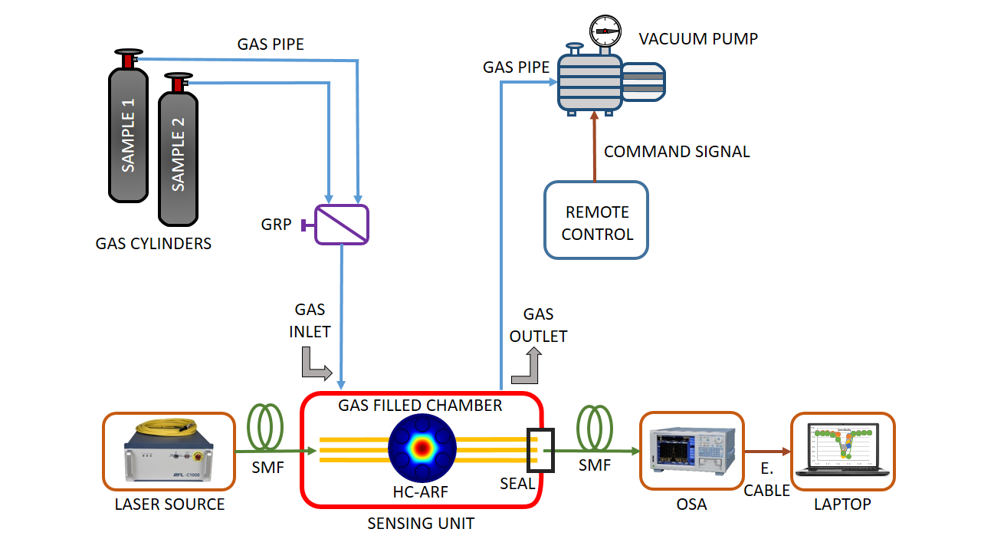

**Fig. 2.** Real life experimental setup of gas sensing with schematic diagram where SMF = Single Mode Fiber, OSA = Optical Spectrum Analyzer.

The real life experimental setup is represented in Fig. 2 with proper schematic diagram. This setup has three major unit such as: (i) Optical Light Source or LASER, (ii) Sensing Unit and (iii) Analysis Unit. Sensing unit has the proposed HC-ARF along with the gas cylinder filled with gas which would be analyzed for sensing. LASER source has Optical Tunable Source (OTS) with distributed feedback circuit to provide THz spectrum. The light is passed to the sensing chamber with a Single Mode Fiber (SMF). The gas which would be tested for sensing is channeled from the respective gas cylinder to the sensing chamber by a gas pipe. This is controlled by Gas Pressure Regulator (GPR) or by Mass Flow Controller (MFC). The chamber pressure is controlled by a vacuum pump which is controlled remotely. Both gas insertion and gas releasing is guided through gas inlet and gas outlet respectively. The optical power provided by the LASER source is absorbed by the sample gas. By Beer-Lambert law, the variation in magnitude of light signal is related to the absorption of the energy of photons by sample gas components [38]. Then it is assessed by Optical Spectrum Analyzer (OSA) which is also connected to the sensing chamber by a SMF. The result about relative sensitivity and other related parameter found by the OSA is represented in a laptop to draw proper conclusion.

**Numerical Analysis:** To find the numerical results, COMSOL Multiphysics (version 5.3a), a simulation mode solver software is used. Using COMSOL Multiphysics, a perfectly-matched layer (PML) was added to the outer most layer of the structure to get accurate simulation results. Both PML and mess size and quality were design based on previous research studies [27,28,39]. In HC-ARF, there are some specific frequencies called resonant frequency where the highest loss occurs. This resonant frequency is dependent on the anti-resonant capillary tube’s thickness, t. The resonant frequency, f of HC-ARF is defined as below equation (1) [28]:

*f [Hz] = .* (1)

Where, c = 3* ms-1, m = resonance order number (integer value such as 1, 2, 3 etc.), nz = RI of base material, Zeonex and t = capillary tube thickness. For first order resonance and t = 0.9 mm, the resonant frequency was found 1.489668 THz. The simulation results are almost similar to this result which is discussed in the next section.

The power fraction, Pf of the fiber is calculated by implementing the below equation (2) [40,41]:

*Pf [%] =* (2)

Here, Sz is z-component of poynting vector and it is defined as , where B and E denote the magnetic and electric field vector component respectively [40]. In equation (2), the integration process is performed over the sample gas selected to be detected (namely core power) and similarly the denominator part is performed over the total region of the fiber (namely total power).

The Differential Optical Absorption Spectroscopy (DOAS) technique is applied in this study to estimate the gas sensitivity. The working principle of the DOAS technique in a nutshell is: a ray of LASER light is used as a signal source and while passing through a gas chamber, gas molecules absorb energy from that ray of light. Then using this power fraction, relative sensitivity coefficient, r is measured by equation (3) [41]:

*r [%] =* (3)

Where, nr and describe the RI of the sample gas and the HC-ARF at the particular operating frequency, respectively.

The EMA is the area where the fundamental mode is confined propagating through the fiber. It is defined as the ratio between the peak energy and the total energy intensities for per unit length of a mode field distribution. The equation (4) is used for determining the value of EMA, Aeff [41,42]:

*=*  (4)

In addition, EMA is very important indicator to find out about CL, bending loss, numerical aperture (NA) etc.

The leakage loss is one of the propagation losses and also known as CL. It is calculated by applying the equation (5) [40]:

*CL [dB/m] = 8.686* (5)

Where, Im(neff) is the imaginary part of RI of base material, Zeonex and f is frequency in Hz. The highest CL is recorded near resonant frequencies.

In THz domain, the EML or bulk material loss product is significant loss due to material absorption and is defined as equation (6) [28,43]:

*EML [dB/m] = 4.34* (6)

Here, is the permeability and is the permittivity of free space and is material absorption coefficient of Zeonex. The EML is significantly lower than the CL in this study. Total loss was found by combining the CL and EML of the respective frequency.

As the study showed better HOMER performance, Cross Talk (CT) is calculated to check transmission performance. Cross talk helps to determine whether there is undesired polarization modes or not and thus indicates to transmission performance. CT depends on fiber length, L and is defined as equation (7) [44,45]:

*CT = 20* (7)

Here, CLHPM and CLVPM are the CLs for HPM and VPM respectively and L is the fiber length. Generally, the longer the fiber length the higher the cross talk.

**Fig. 3.** Relative sensitivity graph both for Fundamental mode and HOMs.

And finally the effects of fiber bending on these parameters. There are two types of loss such as (i) transition bend loss increase when bend radius is reduced and (ii) leakage loss of curved fiber [46]. The study of bending effects starts with a new refractive index for the bent fiber replacing the straight one’s which is achieved by conformal transformation method. This new refractive index follows the following equation (8) [28,47]:

*= n(x, y)(1+* (8)

Here, n’(x, y) and n(x, y) are the RI of bent fiber and straight fiber respectively, x is the bending direction and Rb is the bend-radius.

**Result Analysis & Discussion:**

The sensitivity response is one of the principal parameters in case of any type of HC-ARF based sensors. The sensing procedure abides by Beer-Lambert Law [41]. As from the discussion in the numerical analysis section, it was expected to find relatively high propagation loss near 1.489668 THz. And the simulation has given nearly the similar results. Fig. 3 demonstrates relative sensitivity responses for FMs and HOMs. As the fiber is a HC-ARF, the relative sensitivity is quite high, nearly 99% at several points throughout the tested THz frequency domain. That is at non-resonant frequencies. The frequency domain tested has the range from 1.0 THz to 2.0THz and the resonant frequency is 1.489668 THz. The lowest sensitivity response for FMs (both for HE11 (even)/VPM and HE11 (odd)/HPM) is recorded 78.4% around resonant frequency. HOMs shows relatively lower sensitivity than FM. The lowest sensitivity is 75% for TE01 mode. But it is also observed that, HOMs also shows 99% relative sensitivities at several points if frequency domain. Observing relative sensitivity responses, one thing is clear and that is FMs and HOMs exhibit lower sensitivity response (75% - 85%).

The EMAs are the areas of the fiber core, where most light is concentrated when it is propagated through the HC-ARF. Simulations show that, the effective modes areas are declining while approaching the resonant frequency. It is noticed that, where the EMA is the smallest, the relative sensitivity response is the lowest. And that place is near 1.5 THz. This behavior also justifies the theory of Power Fraction inscribed in equation no (2) in numerical analysis section. The reduction in EMA leads to less power absorption by the sample gas’s molecules in the core region. At that time, the relative sensitivity responses are decreased. Since EMAs of HOMs are smaller compared to FMs’, the sensitivity responses of those HOMs are lower than FMs.

**Fig. 4.** Effective mode area of confined light.

Similar to the sensitivity responses and EMAs, main propagation losses or simply CLs are higher at resonant frequency. As mentioned in the introduction chapter, there is relatively higher CL in this proposed HC-ARF. Fig. 5 represents CLs for FMs and HOMs of the designed HC-ARF from the simulation. Near resonant frequency, 1.6 THz to be exact, maximum loss is 4.73299 dB/m for HE11 (even) fundamental mode. HE11 (odd) fundamental mode also gives maximum CL near resonant frequency which is 4.36361 dB/m. Minimum losses are found at non-resonant frequencies. The minimum CL recorded is 0.00638 dB/m at 1.8 THz frequency. PCF with lower CL values tends to giver better performance. Other higher mode field distributions also gives higher CL than fundamental modes near resonant frequency. Maximum loss for HOMs is 10.8872 dB/m for TE01 mode field distribution. At non-resonant frequencies, even HOMs give relatively lower CL. Minimum loss for HOMs is 0.01071 dB/m at 1.1 THz frequency.

So, it is clear that, CL is higher near resonant frequency both for FMs and HOMs. But at non-resonant frequencies, this proposed HC-ARF gives lower CL with ultra-high sensitivity response.

**Fig. 5.** Confinement loss of FMs and HOMs.

**Fig. 6.** Effective material loss for FMs.

The EMLs are negligibly small in this HC-ARF which is visualized in Fig. 6. These EMLS are negligibly low because of the hollow core nature of the fiber. For FMs, the lowest EML is 0.00139 dB/m at 1.9 THz frequency. But it is seen that, EMLs also begin to increase when light starts to approach resonant frequency. Maximum EML is 0.18277 dB/m for FM. As described in the introduction section, hollow core fiber shows negligibly material absorption loss. The results from simulation also prove that.

**Fig. 7.** HOMER of the proposed fiber.

**Fig. 8.** Cross Talk for various fiber lengths.

**High Order Mode Extinction Ratio and Cross Talk:** Hollow core fiber has core with large diameter. So the propagating light shows several mode field distributions. Whether the fiber is good for single mode transmission or not can be decided by looking at HOMER. HOMER is the ratio of the lowest CL of higher order modes and the CL of the fundamental mode [28,47,48]. These HOMs are the result of high coupling between the HOMs and the cladding modes [47]. HOMER for TM01, TE01, HE21 (even), HE21 (odd) modes are calculated and the ratios between HOMs and FMs are greater than 1. Fig. 7 shows the HOMER graphs of the fiber. The highest HOMER values of for TM01, TE01, HE21 (even), HE21 (odd) are 14, 14, 11, 10.9 which are found at 1.4, 1.0, 1.8, 1.8 THz respectively. Hence, this proposed HC-ARF can provide efficient single mode light propagation and can be used as long transmission fiber. Also greater HOMER provides better modal purity which is desirable for gas sensing applications [49].

Cross talk of the HC-ARF is very low for the fiber length of 1, 2 and 3 meter which is plotted in Fig. 8. Highest crosstalk recorded is 3.21 dB for 1 m long fiber. The crosstalk increases as the fiber length increases which can be described by Beer Laws [45]. It is seen that the crosstalk is less than 10 dB even for 3 m long fiber. The opposite two dip and peak mean that, the loss is significant at 1.5 THz and 1.6 THz and they will get bigger if the length of the fiber is increased.

**Bending Effects on Sensitivity, EMA, CL and EML:** Fiber might bend during experiments and thus can affect the performance of the fiber. To study the effects of fiber-bending on sensitivity, EMA and EML, equation (8) is used for various bend-radii (15 cm, 30 cm, 45 cm). This bending has a great effect on sensitivity, effective area, CL and EML. To understand the effects of bending, bending results have been plotted along with no-bending results of fundamental modes (marked by blue color in the graph). Fig. 9 represents sensitivity responses for various bend-radii. These sensitivity responses are recorded by taking those modes such that HPMs for x-axis bending and VPMs for y-axis bending. Because, VPMs at x-axis bending shows greater CL than HPMs. Similarly, HPMs at y-axis bending shows higher CL than VPMs.

**(a)**

**(b)**

**Fig. 9.** Relative sensitivity responses: (a) x-axis bending, (b) y-axis bending.

Sensitivities drop with the reduction of bend-radius. Without bending or bend-radius = 0 cm, the minimum sensitivity response is 78% for both fundamental modes. With bending, minimum sensitivity responses for HPMs are 64.6%, 60.1% and 51.2% for 45 cm, 30 cm and 15 cm bend-radius respectively and for VPMs are 63.1%, 51.2% and 31.84% for 45 cm, 30 cm and 15 cm respectively. Even after bending the fiber, sensitivity responses are minimum around resonant frequency of the proposed HC-ARF. The EMAs are also changed by the bending of the fiber. This is plotted in Fig. 10.

**(a)**

**(b)**

**Fig. 10.** Effective mode areas: (a) x-axis bending, (b) y-axis bending.

Although it seems that the EMAs change randomly, the minimum EMAs are found near resonant frequency for all bend-radii. With reduction of bend-radius, the EMA decreases to the minimum value: 2.85E-07 m2 whereas the minimum EMA of FM is 1.39E-06 m2.

CLs change drastically with bending. The smaller the bend-radius, the higher the CL both in x-axis bending and y-axis bending. Fig. 11 shows the CLs along with their mode field distributions:

|  |  |  |
| --- | --- | --- |
| Rb = 45 cm | Rb = 30 cm | Rb = 15 cm |

**(a)**

|  |  |  |
| --- | --- | --- |
| Rb = 45 cm | Rb = 30 cm | Rb = 15 cm |

**(b)**

**Fig. 11.** Confinement loss with mode field distributions at Rb = 45 cm, 30 cm, 15 cm: (a) x-axis bending, (b) y-axis bending.

It is observed that, CL of y-axis bending is much higher than the CL of x-axis bending but both get increased by smaller bend-radius. Maximum loss for x-axis bending is 39.26 dB/m where maximum loss for y-axis bending is 64.23 dB/m, bend-radius at 15cm. Fig. 12 shows the inverse relationship between bending loss and bend-radii. It demonstrates that, bending loss increases when fiber bend-radius decreases. There is a critical bend-radius at 30 cm for HPM and at 35 cm for VPM, where the bending loss reaches higher [50]. It can be inferred that HOMER will increase when fiber is bent as CL increases with bending [49].

**Fig. 12.** Increasing bending loss by reducing bend-radius of the fiber

EML also increases with bending because coupling between core and claddings become stronger by bending the fiber. Fig. 13 shows the EMLs of the bent fiber. Near resonant frequency, the EML is much higher than that of non-resonant frequencies. For x-axis bending having 30 cm rand-radius, the maximum EML is 1.28 dB/m at 1.6 THz. And for y-axis bending having 15 cm band-radius, the maximum EML is 0.934 dB/m at 1.4 THz.

**(a)**

**(b)**

**Fig. 13.** Effective material loss: (a) x-axis bending, (b) y-axis bending.

Although these results of the sensor deteriorate with bending (thus reducing sensor’s performance), HC-ARF can support smaller bend-radii compared to other Photonic Bandgap Fibers (PBGF) [49].

**Conclusion:** This study can be summarized by saying that, the designed HC-ARF showed marvelous sensitivity result with low propagation loss and very low material absorption loss. The maximum sensitivity offered by the fiber is 99.9538% at 2.0 THz with the minimum CL of 0.00638 dB/m at 1.8 THz. The measured lowest EML is 0.0013896 dB/m at 1.9 THz. The HOMER of the proposed HC-ARF is excellent which indicates the single modality in transmission of the HC-ARF with the lowest cross talk of 0.00029734 dB at 1.0 THz for 1 meter long fiber. The design of the fiber is so simple that it can be implemented very easily. With such great results, it has the potential to fulfill the purpose of this study that is a PCF for highly sensitive gas sensor.

**References:**

1. Mitu, S.A., Ahmed, K., Al Zahrani, F.A., Grover, A., Rajan, M.S.M. and Moni, M.A., 2021. Development and analysis of surface plasmon resonance based refractive index sensor for pregnancy testing. Optics and Lasers in Engineering, 140, p.106551.
2. Jabin, M.A., Ahmed, K., Rana, M.J., Paul, B.K., Islam, M., Vigneswaran, D., Uddin, M.S.: Surface plasmon resonance based titanium coated biosensor for cancer cell detection. IEEE Photonics J. 11(4), 1–10 (2019)
3. Ahmed, K., Ahmed, F., Roy, S., Paul, B.K., Aktar, M.N., Vigneswaran, D., Islam, M.S.: Refractive index-based blood components sensing in terahertz spectrum. IEEE Sens. J. 19(9), 3368– 3375 (2019)
4. Atiqullah, S.M., Palit, A., Reja, M.I., Akhtar, J., Fatema, S., Absar, R.: Detection of harmful food additives using highly sensitive photonic crystal fiber. Sens. Bio-Sens. Res. 23, 100275 (2019)
5. M.M. Hasan, S. Sen2, M.J. Rana, B.K. Paul, M.A. Habib, G.M. Daiyan, K. Ahmed, Heptagonal photonic crystal fiber based chemical sensor in THz regime, in: ICIEV& IVPR, 2019.
6. U. Langematz, Stratospheric ozone: down and up through the anthropocene, ChemTexts 5 (2019).
7. Allen, M., Frame, D., Huntingford, C. et al. Warming caused by cumulative carbon emissions towards the trillionth tonne. Nature 458, 1163–1166 (2009).
8. M.O. Saucedo, S.H.S. Rodríguez, C.F.A. Flores, R.B. Valenzuela, M.A.L. Luna, Effects of ultraviolet radiation (UV) in domestic animals, Review 10 (2019) 416–432.
9. Z.A. Zaky, A.M. Ahmed, A.S. Shalaby, A.H. Aly, Refractive index gas sensor based on the Tamm state in a one-dimensional photonic crystal: theoretical optimization, Sci. Rep. 10 (2020) 9736.
10. A. Klini, M. Androulidaki, D. Anglos, Low energy pulsed laser excitation in UV enhances the gas sensing capacity of photoluminescent ZnO, Nanohybrids 19 (2019) 5490.
11. S. Mahajana, S. Jagtap, Metal-oxide semiconductors for carbon monoxide (CO) gas sensing: a review, Appl. Mater. Today 18 (2019), 100483.
12. I. Constantinoiu, D. Miu, C. Viespe, Surface Acoustic Wave Sensors for Ammonia Detection at Room Temperature Based on SnO2/Co3O4 Bilayers, Journal of Sensors 2019 (2019). ID 8203810.
13. V. Balasubramani, S. Chandraleka, T.S. Rao, R. Sasikumar, M.R. Kuppusamy, T. M. Sridhar, Advances in electrochemical impedance spectroscopy based toxic gas sensors using semiconducting metal oxides, J. Electrochem. Soc. 167 (2019).
14. R.E. Owyeung, M.J. Panzer, S.R. Sonkusale, Colorimetric gas sensing washable threads for smart textiles, Scientific reports 167 (1) (2019) 1–8.
15. J.H. Bang, M.S. Choi, A. Mirzaei, W. Oum, S. Han, S.S. Kim, H.W. Kim, Porous Si/ SnO2 nanowires heterostructures for H2S gas sensing, Ceram. Int. 46 (2020) 604–611.
16. M. Njegovec, D. Donlagic, A Fiber-optic gas sensor and method for the measurement of refractive index dispersion in NIR, Sensors 20 (2020) 3717.
17. Mitu, S.A., Ahmed, K., Al Zahrani, F.A., Abdullah, H., Hossain, M.N. and Paul, B.K., 2021. Micro-Structure Ring Fiber–Based Novel Magnetic Sensor with High Birefringence and High Sensitivity Response in Broad Waveband. Plasmonics, pp.1-9.
18. Mitu, S.A., Ahmed, K., Abdullah, H., Paul, B.K., Al-Zahrani, F.A., Patel, S.K. and Rajan, M.M., 2021. Exploring the optical properties of exposed-core-based photonic-crystal fibers. Journal of Computational Electronics, pp.1-10.
19. Mitu, S.A., Dey, D.K., Ahmed, K., Paul, B.K., Luo, Y., Zakaria, R. and Dhasarathan, V., 2020. Fe3O4 nanofluid injected photonic crystal fiber for magnetic field sensing applications. Journal of Magnetism and Magnetic Materials, 494, p.165831.
20. Abdullah, H., Mitu, S.A. and Ahmed, K., 2020. Magnetic Fluid-Injected Ring-Core-Based Micro-structured Optical Fiber for Temperature Sensing in Broad Wavelength Spectrum. Journal of Electronic Materials, 49, pp.4969-4976.
21. Md. Ranju Sardar, Mohammad Faisal, Kawsar Ahmed, Hybrid porous core photonic crystal fiber sensor for monitoring nitrous oxide gas, Sensing and Bio-Sensing Research, Volume 30, 2020, 100389, ISSN 2214-1804
22. V. Kaur, S. Singh, Design approach of solid-core photonic crystal fiber sensor with sensing ring for blood component detection, J. Nanophot. 13 (2019) 026011–026012.
23. A.S.H. Rabeea, M.F.O. Hameed, A.M. Heikal, S.S.A. Obayya, Highly sensitive photonic crystal fiber gas sensor, Optik 188 (2019) 78–86.
24. Y. Zhang, L. Xue, D. Qiao, Z. Guang, Porous photonic-crystal fiber with near-zero ultra-flattened dispersion and high birefringence for polarization-maintaining terahertz transmission, Optik 19 (2019) 163817.
25. R. Yu, Y. Chen, L. Shui, L. Xiao, Hollow-Core photonic crystal Fiber gas sensing, sensors 20 (2020) 2996.
26. Poletti, F., 2014. Nested antiresonant nodeless hollow core fiber. Optics express, 22(20), pp.23807-23828.
27. Habib, M.S., Bang, O. and Bache, M., 2015. Low-loss hollow-core silica fibers with adjacent nested anti-resonant tubes. Optics express, 23(13), pp.17394-17406.
28. Mollah, M.A., Habib, M.S. and Habib, M.S., 2020. Novel hollow-core asymmetric conjoined-tube anti-resonant fiber for low-loss THz wave guidance. OSA Continuum, 3(5), pp.1169-1176.
29. Krzempek, K.; Abramski, K.; Nikodem, M. Kagome hollow core fiber-based mid-infrared dispersion spectroscopy of methane at sub-ppm levels. Sensors **2019**, 19, 3352.
30. Nikodem, M.; Gomolka, G.; Klimczak, M.; Pysz, D.; Buczynski, R. Demonstration of mid-infrared gas sensing using an anti-resonant hollow core fiber and a quantum cascade laser. Opt. Express **2019**, 27, 36350–36357.
31. Yao, C.; Gao, S.; Wang, Y.; Wang, P.; Jin, W.; Ren, W. Silica hollow-core negative curvature fibers enable ultrasensitive mid-infrared absorption spectroscopy. J. Lightwave Technol. **2020**, 38, 2067–2072.
32. Culshaw, B.; Stewart, G.; Dong, F.; Tandy, C.; Moodie, D. Fibre optic techniques for remote spectroscopic methane detection-from concept to system realisation. Sens. Actuat. B Chem. **1998**, 51, 25–37.
33. Uebel, P., Günendi, M.C., Frosz, M.H., Ahmed, G., Edavalath, N.N., Ménard, J.M. and Russell, P.S.J., 2016. Broadband robustly single-mode hollow-core PCF by resonant filtering of higher-order modes. Optics letters, 41(9), pp.1961-1964.
34. Argyros, A., 2013. Microstructures in polymer fibres for optical fibres, THz waveguides, and fibre-based metamaterials. International Scholarly Research Notices, 2013.
35. Paul, B.K. and Ahmed, K., 2019. Highly birefringent TOPAS based single mode photonic crystal fiber with ultra-low material loss for Terahertz applications. Optical Fiber Technology, 53, p.102031.
36. Anthony, J., Leonhardt, R., Argyros, A. and Large, M.C., 2011. Characterization of a microstructured Zeonex terahertz fiber. JOSA B, 28(5), pp.1013-1018.
37. Kreysing, M., Ott, D., Schmidberger, M.J., Otto, O., Schürmann, M., Martín-Badosa, E., Whyte, G. and Guck, J., 2014. Dynamic operation of optical fibres beyond the single-mode regime facilitates the orientation of biological cells. Nature communications, 5(1), pp.1-6.
38. Sardar, M.R., Faisal, M. and Ahmed, K., 2020. Hybrid porous core photonic crystal fiber sensor for monitoring nitrous oxide gas. Sensing and Bio-Sensing Research, 30, p.100389.
39. Belardi, W. and Knight, J.C., 2014. Hollow antiresonant fibers with reduced attenuation. Optics letters, 39(7), pp.1853-1856.
40. Hasanuzzaman, G.K.M., Iezekiel, S., Markos, C. and Habib, M.S., 2018. Hollow-core fiber with nested anti-resonant tubes for low-loss THz guidance. Optics Communications, 426, pp.477-482.
41. Paul, B.K., Ahmed, K., Dhasarathan, V., Al-Zahrani, F.A., Aktar, M.N., Uddin, M.S. and Aly, A.H., 2020. Investigation of gas sensor based on differential optical absorption spectroscopy using photonic crystal fiber. Alexandria Engineering Journal, 59(6), pp.5045-5052.
42. Abdelaziz, I., AbdelMalek, F., Ademgil, H., Haxha, S., Gorman, T. and Bouchriha, H., 2010. Enhanced effective area photonic crystal fiber with novel air hole design. Journal of lightwave technology, 28(19), pp.2810-2817.
43. Atakaramians, S., Afshar, S., Fischer, B.M., Abbott, D. and Monro, T.M., 2008. Porous fibers: a novel approach to low loss THz waveguides. Optics Express, 16(12), pp.8845-8854.
44. Mollah, M.A., Rana, S. and Subbaraman, H., 2020. Polarization filter realization using low-loss hollow-core anti-resonant fiber in THz regime. Results in Physics, 17, p.103092.
45. Chen, L., Zhang, W., Zhang, Z., Liu, Y., Sieg, J., Zhang, L., Zhou, Q., Wang, L., Wang, B. and Yan, T., 2014. Design for a single-polarization photonic crystal fiber wavelength splitter based on hybrid-surface plasmon resonance. IEEE photonics journal, 6(4), pp.1-9.
46. Love, J.D. and Durniak, C., 2007. Bend loss, tapering, and cladding-mode coupling in single-mode fibers. IEEE Photonics Technology Letters, 19(16), pp.1257-1259.
47. Habib, M.S., Antonio-Lopez, J.E., Markos, C., Schülzgen, A. and Amezcua-Correa, R., 2019. Single-mode, low loss hollow-core anti-resonant fiber designs. Optics express, 27(4), pp.3824-3836.
48. Meng, F.C., Liu, B.W., Li, Y.F., Wang, C.Y. and Hu, M.L., 2016. Low loss hollow-core antiresonant fiber with nested elliptical cladding elements. IEEE Photonics Journal, 9(1), pp.1-11.
49. Poletti, F., 2014. Nested antiresonant nodeless hollow core fiber. Optics express, 22(20), pp.23807-23828.
50. Günendi, M.C., 2018. Numerical Modelling of Hollow-Core Photonic Crystal Fibers.